3.6 I can select and use different elements to control environments for collaborative technologies

I am going to demonstrate that I can add iframes and embed other sites and videos into a website:

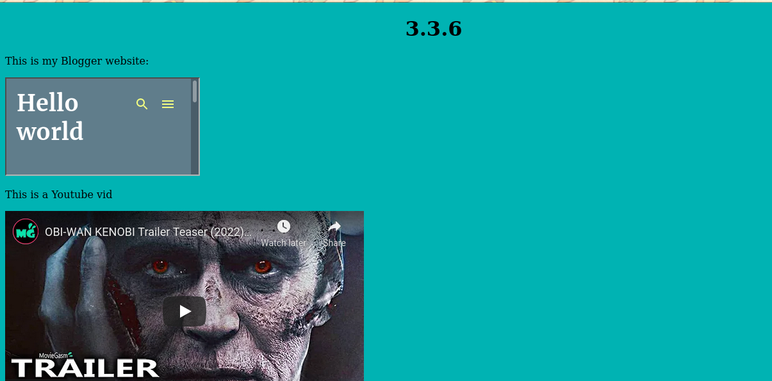

[The above image shows that I have embedded a Blogger site and a Youtube video onto a website]

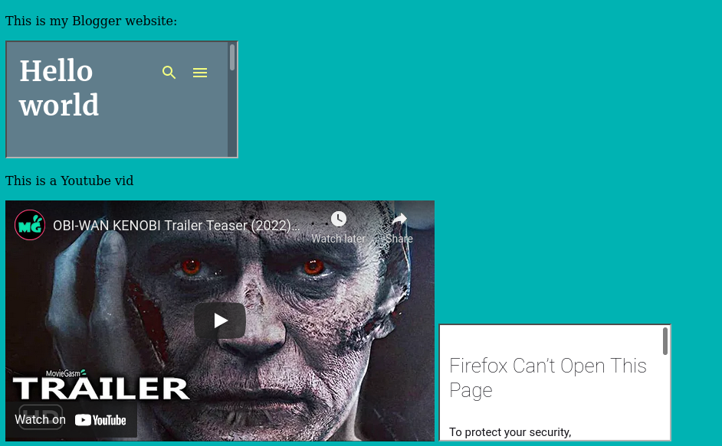

[The above image shows that the Adobe photoshop image link won't show on Firefox]

I added a logo from Adobe's website to see if it I could copy the logo onto my website but Firefox won't let me show it to protect my security. This could be because the website is out of their control if linked through an iframe compared to a actual link that they can verify.